Nielsen Stand Alone

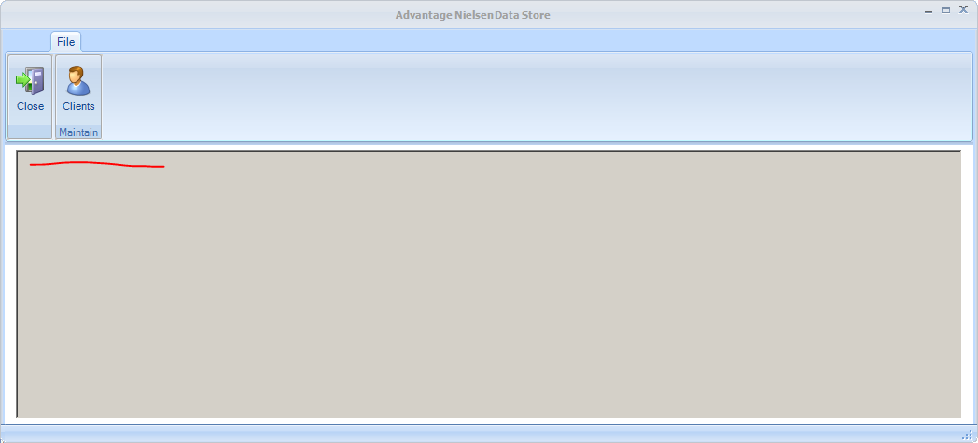

Area with red line will show SignalR activity – notifications to our clients and replies back.

* Client Maintenance – this is where we list and add/edit/delete those clients that have purchased Nielsen module

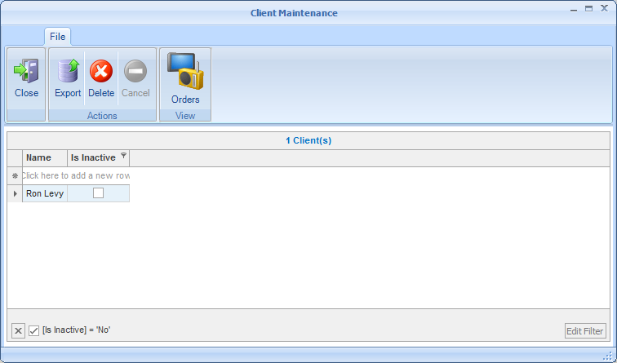

* Orders – each email we would get on a client would be an order describing the year/months and markets they have purchased.

